23rd -27th March 2020

Hello,
Hope you are all well and keeping safe in the difficult time.
This week’s for activities, ideas and suggestions are based on encouraging the children to be active to keep their physical health and well -being safe.
As the weather is improving a lot of these suggestion can be indoor or outdoor activities
Health and well-being
It is very important to think of our physical health and well-being throughout this time.
http://sportwales.org.uk/community-sport/education/play-to-learn.aspx On the sport Wales website there are a lot of activities linked to practical team skills and storytelling that can help keep our mind and bodies active. The link I have attached is for the introduction for the play to learn resources, which will introduce the characters and the lay out of the activities and sessions.
Go Noddle is another lovely to keep active https://app.gonoodle.com/sign-up?source=GNlogin . You can sign up for it on this link.
Literacy and Reading:
Here is a link to different stories read by celebrities. Here is a link to the story ‘The Hula -Hoopin queen’ read by Oprah : https://www.storylineonline.net/books/hula-hoopin-queen/
Here is some sensory activities for being outdoors:
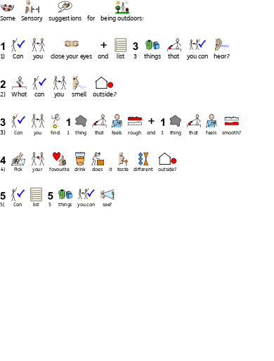
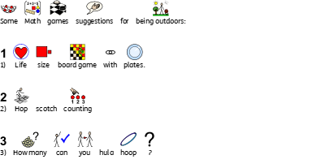
Mathematics and Numeracy
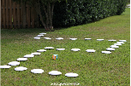

I will be adding more activities next week. Wishing you safe and healthy week.

